Perineal preparation and massage
This technique is intended to help your partner to prepare your perineum so that it will be more able to stretch successfully during the birthing of your baby's head. This procedure should be commenced about 6 weeks before your due date.
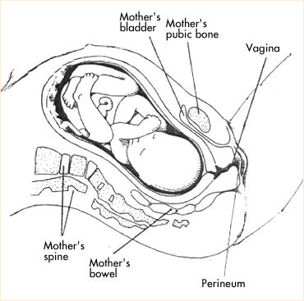
Firstly, find a comfortable position so that your partner will have access to your perineum. You may want to sit up on the bed supported by pillows or lie in your side with your top leg slightly more bent than the bottom one. Another option is to make yourself comfortable over a beanbag or a pile of pillows.
Have your partner massage your perineal area with almond oil or coconut oil for a few minutes allowing you time to relax and get comfortable with the sensation.
Your partner will then insert two fingers along the back of the vaginal wall. He should apply firm, consistent, parallel, pressure on the perineum, keeping his fingers straight.
When you feel a burning sensation ask him to stop. He should hold the pressure as you breathe deeply and relax into the sensation. The burning feeling will subside. Let your partner know when this has happened and he will gently stretch a little more before releasing the pressure. Repeat two more times.
Continue to do this each day until your partner finds it difficult to cause the burning sensation. When this happens he will use three fingers and continue in the same way until it is again difficult to get to a point of causing a burning sensation. Then increase to four fingers.
You and your partner will be aware of the increased stretch of your perineum as you do this procedure. When you get to a point of maximum stretch, do the procedure every other day to maintain it.

